

Individual Assessment Coversheet
To be attached to the front of the assessment.
Campus: Pretoria
Faculty: Information Technology
Module Code: ITTFA4-14
Group: 1
Lecturer’s Name: Mr. M.L. Mashabela
Student Full Name: Lesedi Modipadi Ramaesele Chuene
Student Number: eduv4828876

Indicate | Yes | No
Plagiarism report attached

Declaration:
I declare that this assessment is my own original work except for source material explicitly acknowledged. I also declare that this assessment or any other of my original work related to it has not been previously, or is not being simultaneously, submitted for this or any other course. I am aware of the AI policy and acknowledge that I have not used any AI technology to generate or manipulate data, other than as permitted by the assessment instructions. I also declare that I am aware of the Institution’s policy and regulations on honesty in academic work as set out in the Conditions of Enrolment, and of the disciplinary guidelines applicable to breaches of such policy and regulations.

Signature  LMR CHUENE | Date  24/03/2026

Lecturer’s Comments:

Marks Awarded: |  | %
Signature | Date

Eduvos (Pty) Ltd. (formerly Pearson Institute of Higher Education) is registered with the Department of Higher Education and Training as a private higher education institution under the Higher Education Act, 101, of 1997. Registration Certificate number: 2001/HE07/008

TITLE PAGE
This is an ITTFA4-14 Project (Milestone 1) by Chuene Lesedi student number eduv4828876, a student of the Eduvos institution at the Pretoria campus. This module is being lectured by Mr Mashabela. This Project is due on 27/03/2026.

Table of Contents

- Cover Page………………………………………………………………….………………1-2
- Title Page………………………………………………………………………………………3
- Table of Contents……………………………………………………………….…………….4

- Wireframes……………………………………………………………………………………...5-9
- Use case diagram……………………………………………………………………….………10
- Collaborator Responsibility Cards…………………………………………………………11-12
- Context diagram………………………………………………………...……………………….13
- Data flow diagram…………………………………………………………...………………….14
- Database design…………………………………………………………...……………………15
- Class diagram………………………………………………………..………………………….16

- Bibliography………………………………………………………………………………17-18

- WIREFRAMES

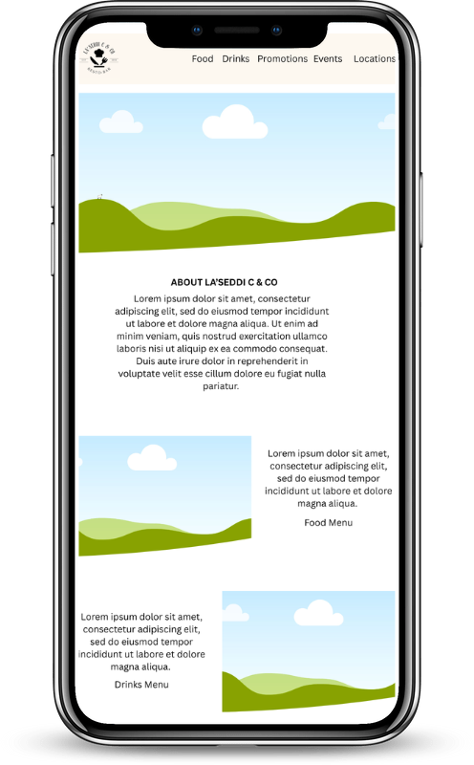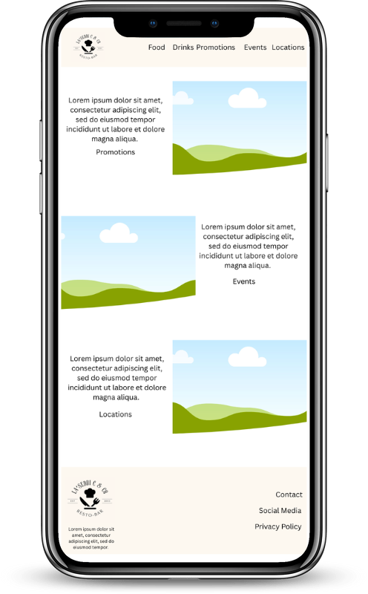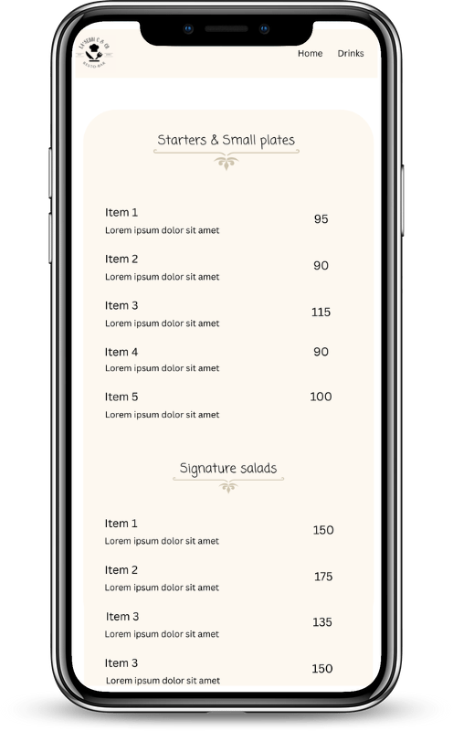

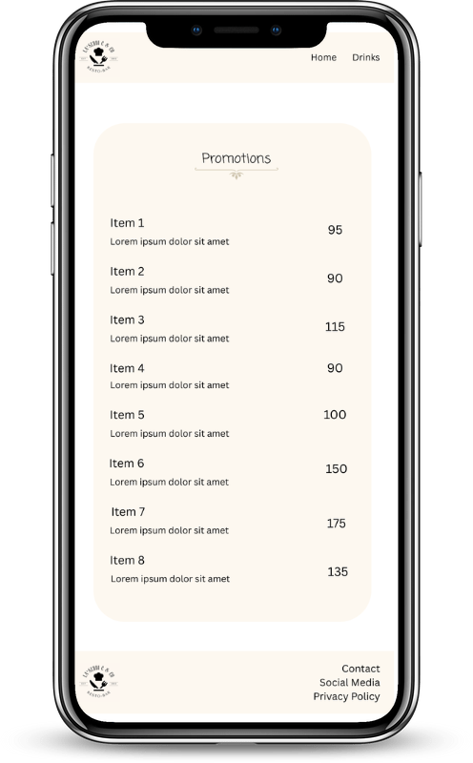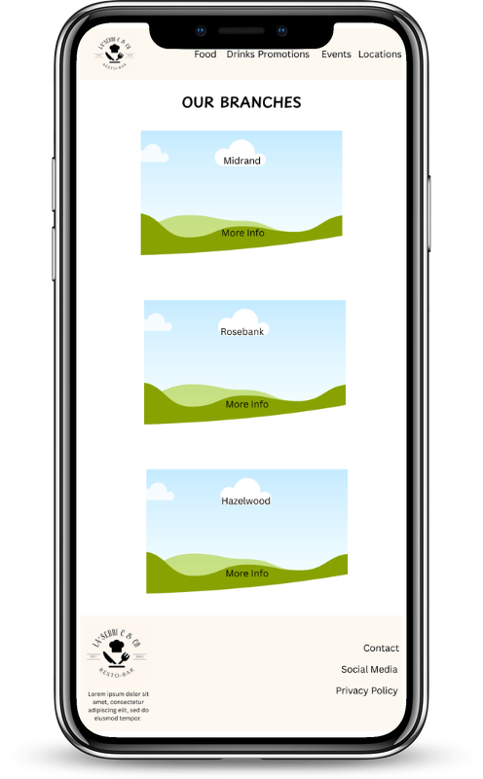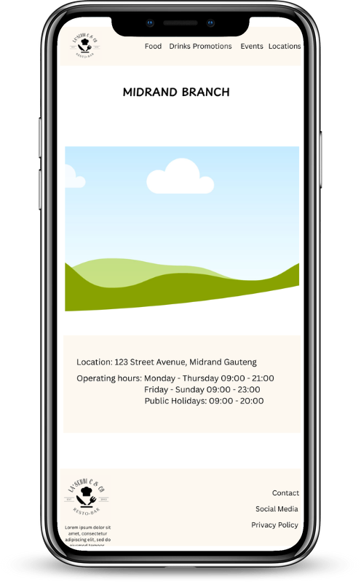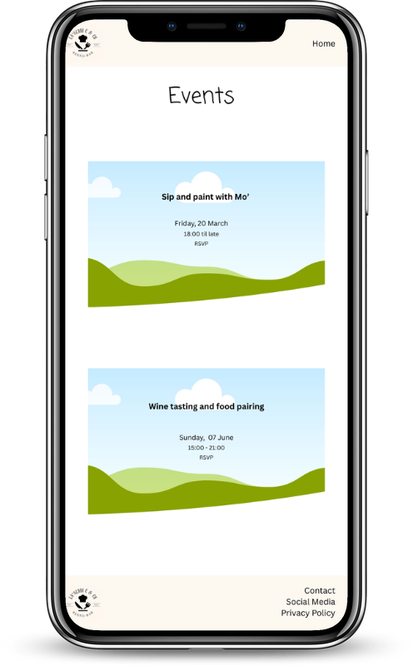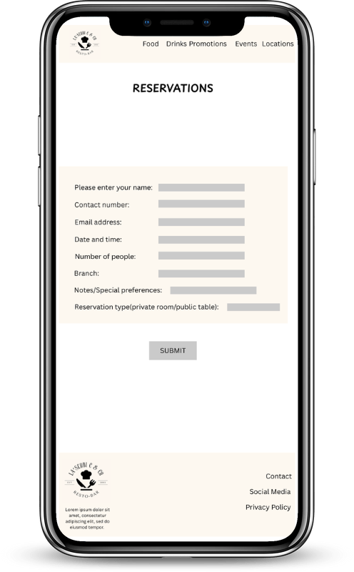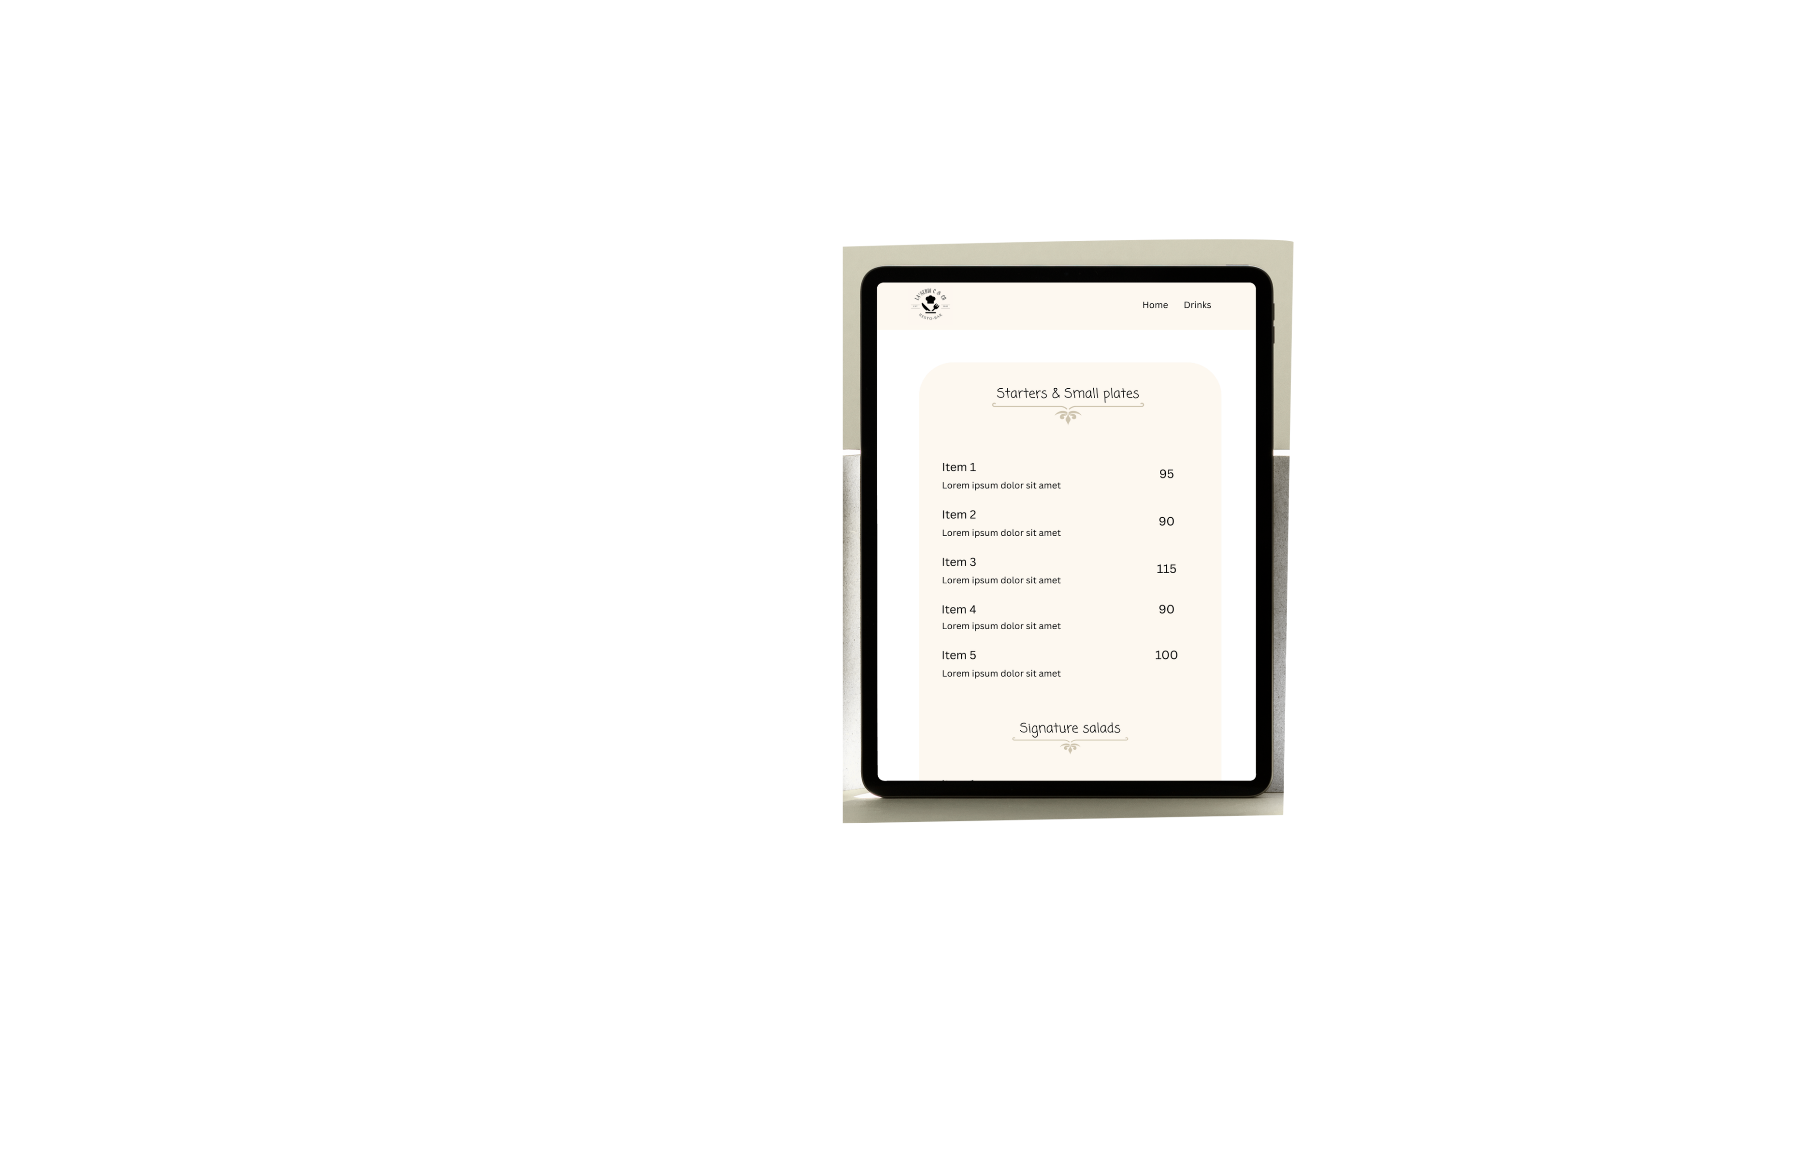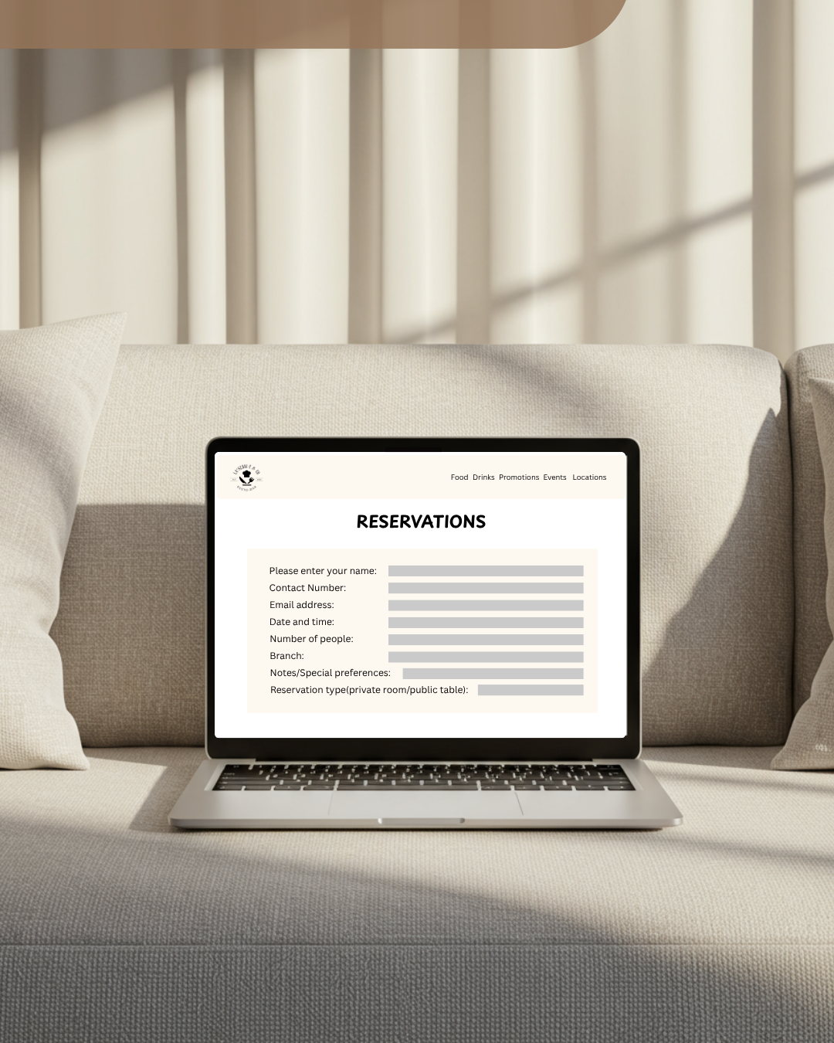

- USE CASE DIAGRAM

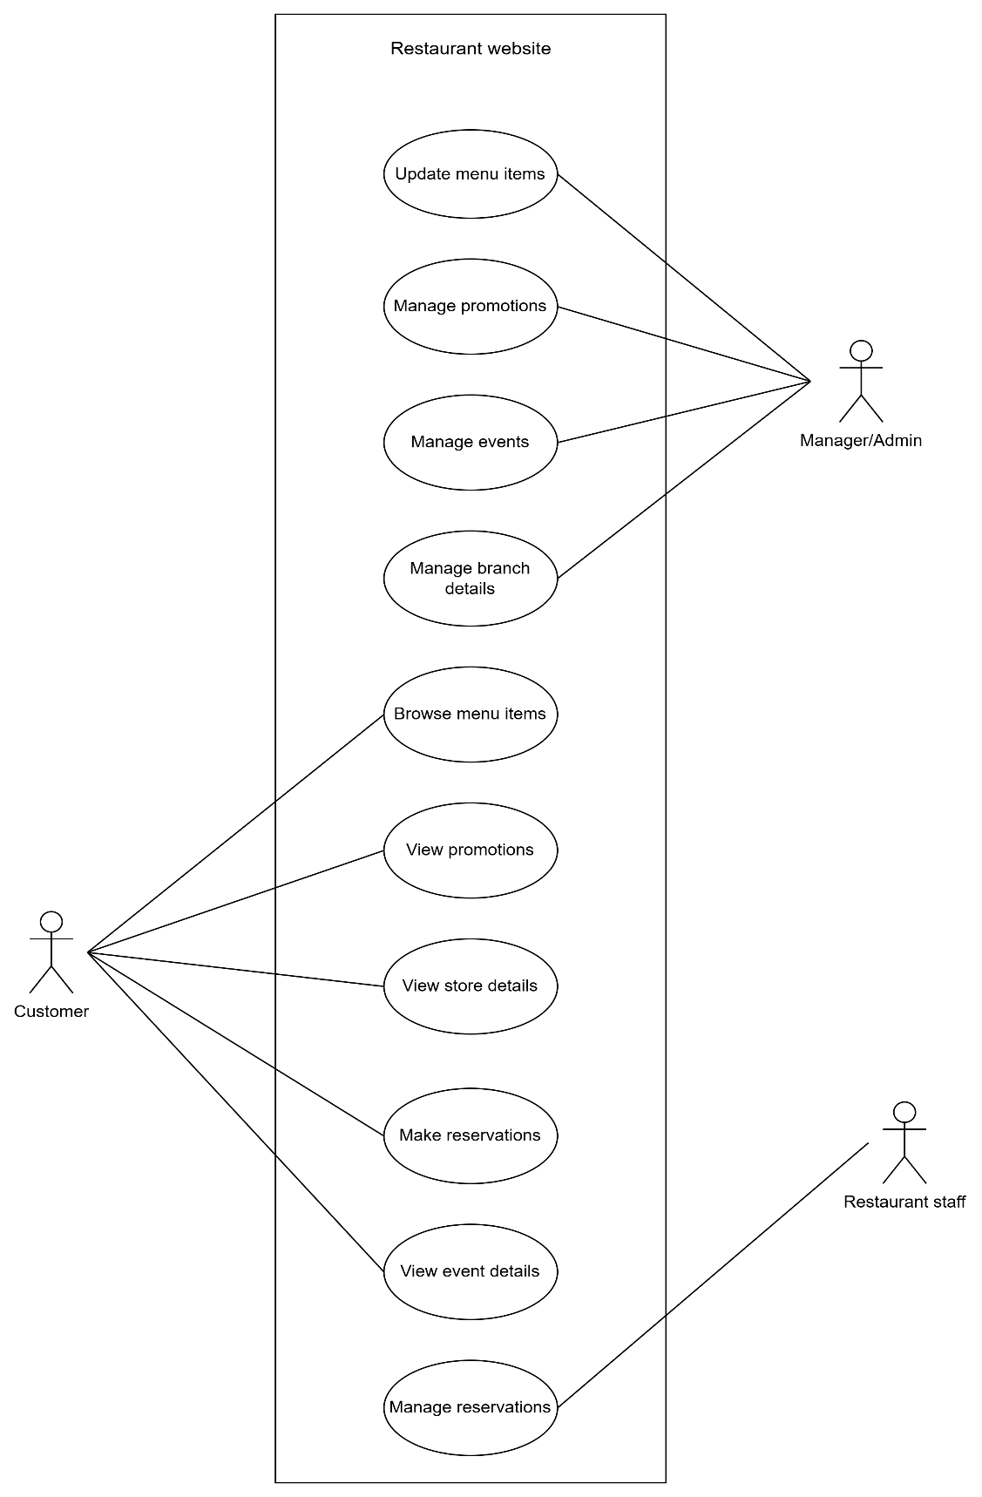

- (A. Dennis, 2021).
- The diagram above shows the main actors in my restaurant website and the various activities that they will be engaging in on the website.
- CLASS RESPONSIBILITY COLLABORATOR CARDS

CRC Card 1 Branch
Card Name | Branch
Responsibilities | Show branch details  Provide table access Manage promotions | Collaborators | Table  Reservations  Promotions

CRC Card 2 Table
Card Name | Table
Responsibilities | Manage seating arrangements  Track table availability | Collaborators | Branch  Reservations  Customer

CRC Card 3 Reservations
Card Name | Reservations
Responsibilities | Manage booking details  Allow for reservation modification | Collaborators | Customer  Branch  Table

CRC Card 4 Customer
Card Name | Customer
Responsibilities | Store customer information  Manage reservations  Browse menu  View store location  View promotions  View event details | Collaborators | Reservations  Branch  MenuItems  Promotions  Events  Events

CRC Card 5 Category
Card Name | Category
Responsibilities | Group menu items | Collaborators | MenuItems

CRC Card 6 MenuItems
Card Name | MenuItems
Responsibilities | Represent dishes  Provide dish details | Collaborators | Category  Branch

CRC Card 7 Promotions
Card Name | Promotions
Responsibilities | Show running specials | Collaborators | Branch  Customer

CRC Card 8 Events
Card Name | Events
Responsibilities | Manage events thrown at branch | Collaborators | Branch  Customer  Reservations

- (A. Dennis, 2021), (Kumari, 2024).
- The cards above show the various classes in my restaurant website as well as their responsibilities and the classes that they will be collaborating with.

- CONTEXT DIAGRAM

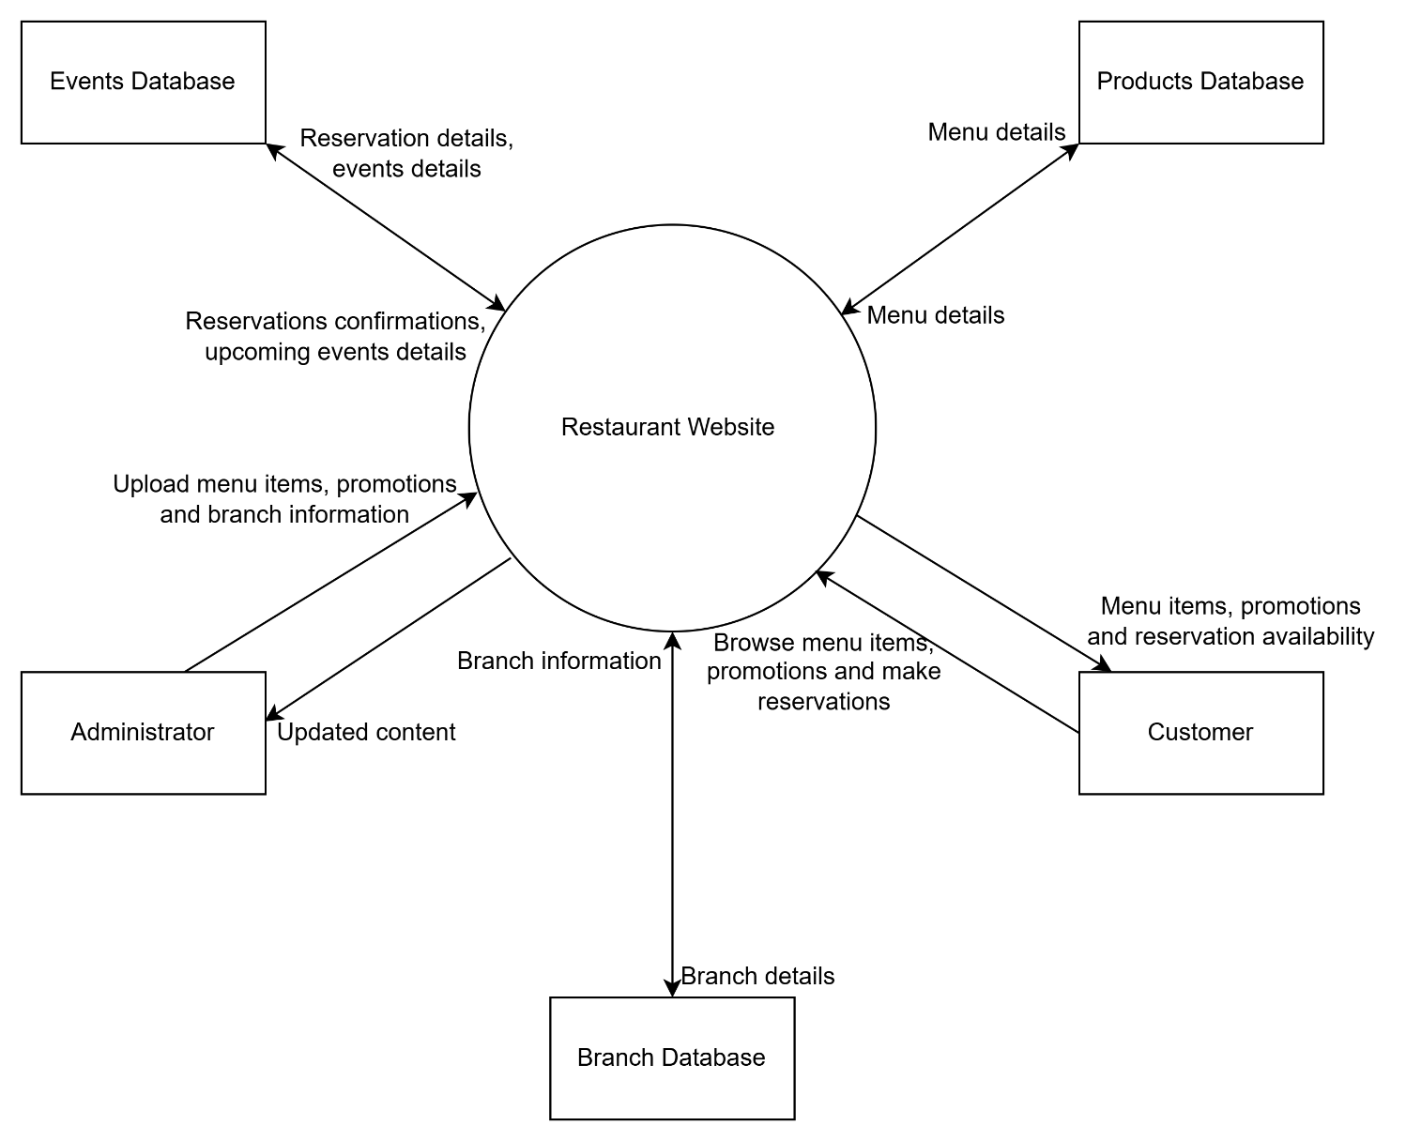

- (Reddy, 2024), (Hansen, 2025), (Pedriquez, 2025).
- The diagram above shows how the restaurant website will be interacting with the various external entities. These external entities are the various databases, the administrator as well as the customer. It further shows the data flow between the restaurant website and its external entities.
- DATA FLOW DIAGRAM

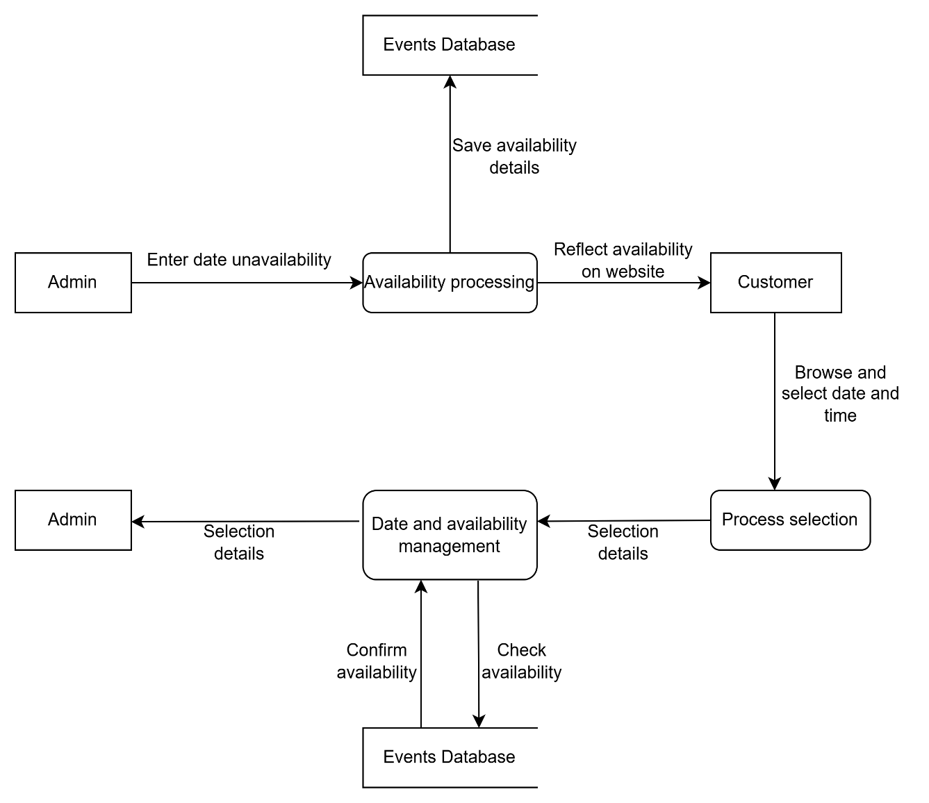

- (Patni, 2025), (Patterson, 2025), (Team, 2025).
- The diagram above shows the flow of information, actors and steps in the restaurant website. It shows the flow when a user wants to make a reservation. Before this can happen, the restaurant administrators first enter the dates where reservations have already been made so that when users make reservations, they make them on dates that are available to avoid disappointments.

- DATABASE DESIGN

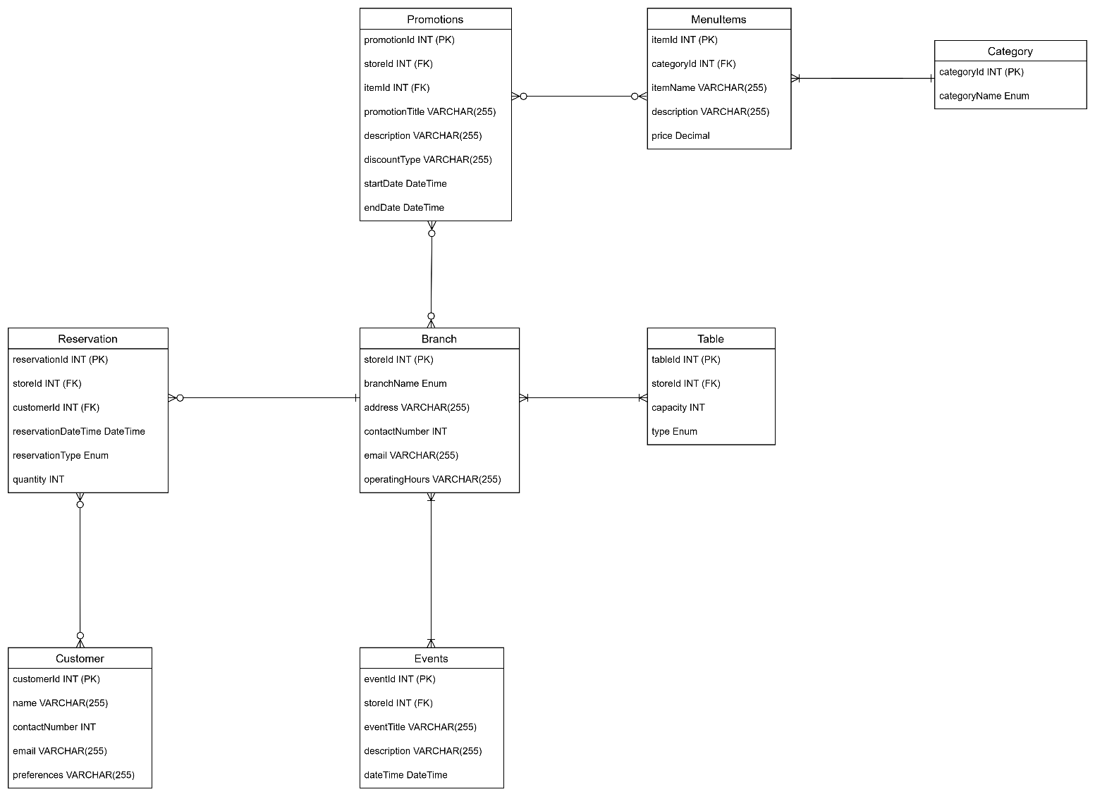

- (Anon., 2022), (Watt, n.d.), (Perera, 2026).
- The diagram above shows the tables as well as the entities involved in the restaurant design. It further shows the relationships between the tables and the entity types.

- CLASS DIAGRAM

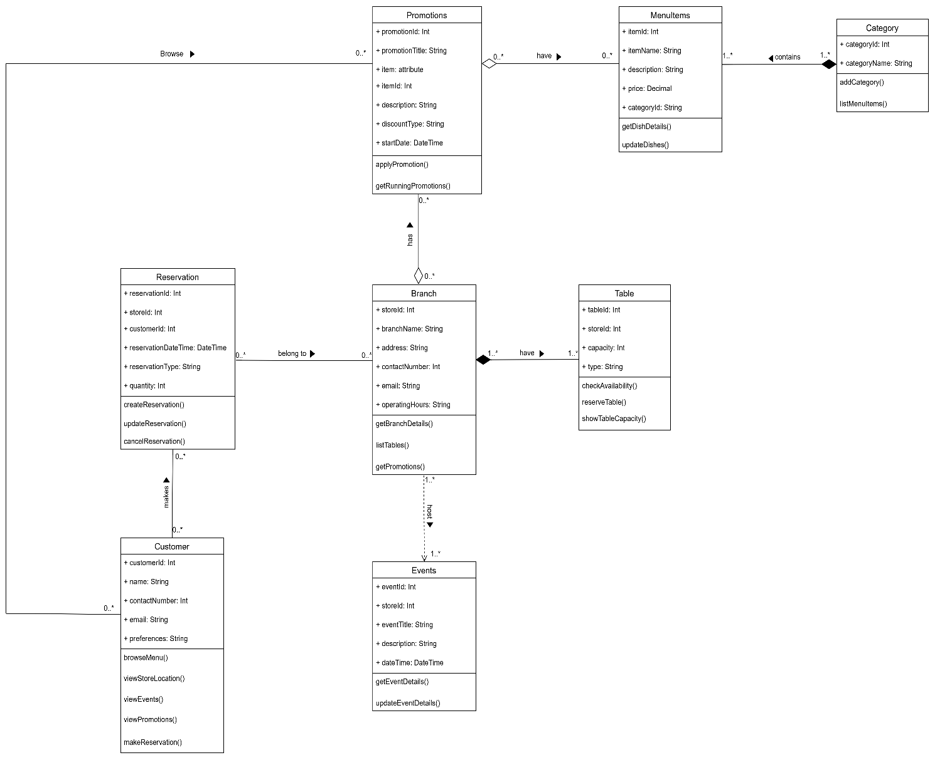

- (Rani, 2026), (Silva, 2026), (Singh, 2026).
- The diagram above shows the classes involved in the restaurant website as well as their entities, methods and entity types. It further shows the relationships between the classes.

Works Cited

A. Dennis, B. W. D. T., 2021. Business Process and Functional Modelling. In: J. Manias, ed. System Analysis and design. Hoboken: Lise Johnson, pp. 128-135.
A. Dennis, B. W. D. T., 2021. Structural Modelling. In: J. Manias, ed. System Analysis and design. Hoboken: Lise Johnson, pp. 178-180.
Anon., 2022. softwareideas. [Online]
Available at: https://www.softwareideas.net/erd-relation-arrows
[Accessed 25 March 2026].
Hansen, B., 2025. mural. [Online]
Available at: https://www.mural.co/blog/context-diagrams
[Accessed 24 March 2026].
Kumari, R., 2024. geeks for geeks. [Online]
Available at: https://www.geeksforgeeks.org/system-design/class-responsibility-collaboration-card/
[Accessed 30 March 2026].
Patni, S., 2025. geeks for geeks. [Online]
Available at: https://www.geeksforgeeks.org/software-engineering/what-is-dfddata-flow-diagram/
[Accessed 25 March 2026].
Patterson, B., 2025. rudderstack. [Online]
Available at: https://www.rudderstack.com/blog/data-flow-diagram/
[Accessed 25 March 2026].
Pedriquez, D., 2025. venngage. [Online]
Available at: https://venngage.com/blog/context-diagram/
[Accessed 31 March 2026].
Perera, N., 2026. creately. [Online]
Available at: https://creately.com/guides/er-diagram-symbols/
[Accessed 25 March 2026].
Rani, B., 2026. geeksforgeeks. [Online]
Available at: https://www.geeksforgeeks.org/system-design/unified-modeling-language-uml-class-diagrams/
[Accessed 25 March 2025].
Reddy, M. N. S., 2024. geeks for geeks. [Online]
Available at: https://www.geeksforgeeks.org/system-design/context-diagrams/
[Accessed 24 March 2026].
Silva, N., 2026. creately. [Online]
Available at: https://creately.com/guides/class-diagram-relationships/
[Accessed 25 March 2026].
Singh, A. P., 2026. algomaster. [Online]
Available at: https://algomaster.io/learn/lld/class-diagram
[Accessed 25 March 2026].
Team, M., 2025. miro. [Online]
Available at: https://miro.com/diagramming/what-is-a-data-flow-diagram/
[Accessed 30 March 2026].
Watt, A., n.d. opentextbc. [Online]
Available at: https://opentextbc.ca/dbdesign01/chapter/chapter-8-entity-relationship-model/
[Accessed 25 March 2026].

